COMP 0560: Artificial Intelligence I
Final Exam
Fall 1999

Name_____________________________________

There is a total of 145 points. Your grade on this exam will be determined as follows:

Your_Grade = Exam_Score/145

Chapter 1: Introduction to AI

- [5pts] In the textbook, the authors discuss 4 approaches for (in defining) Artificial Intelligence. List and briefly describe them?

- [5pts] What is the physical symbol system hypothesis?

COMP 0560: Artificial Intelligence I
Final Exam
Fall 1999

Chapter 2: Agents

- [10pts] Consider the problem of developing a team of N robots in an effort to investigate the surface of Mars. Each of the robots would probably need to be a type of ___________________________ agent (or some combination of those mentioned) that would need to be able to operate in a ________________________ environment.

- [5pts] What is an ideal rational agent?

COMP 0560: Artificial Intelligence I
Final Exam
Fall 1999

Chapter 3 & 4: Uninformed & Informed Search

- [12pts] Using the Figure below, what order will the nodes be expanded using (a) iterative deepening, (b) uniform-cost search, (c) A* and (d) IDA*.

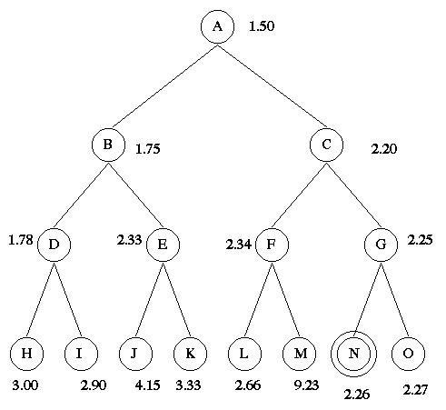

COMP 0560: Artificial Intelligence I
Final Exam
Fall 1999

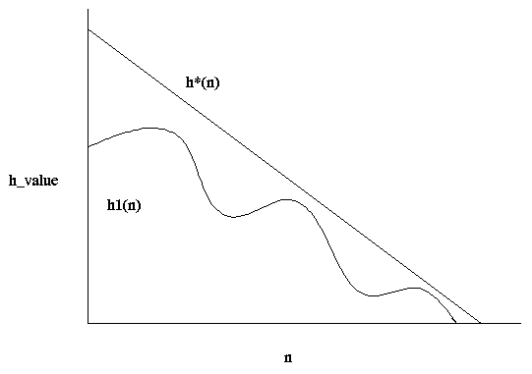

- [10pts] Given the figure above. Answer the following questions (Let h*(n) represent the actual cost of going from state n to the goal).

- Is h1(n) admissible?

- Is h1(n) monotonic? If not, what would a monotonic version of h1(n) look like? [Hint: think carefully about the pathmax equation]

COMP 0560: Artificial Intelligence I
Final Exam
Fall 1999

- [12pts] The puzzle below consists of 3 black tiles, 3 white tiles, and 1 empty space. A tile can move into the empty space with a cost of 1. A tile can jump over 1 or 2 tiles into the empty space with a cost equal to the number of tiles jumped. Shown below are the start and goal states. The position of the empty space is not a concern (in the goal state).

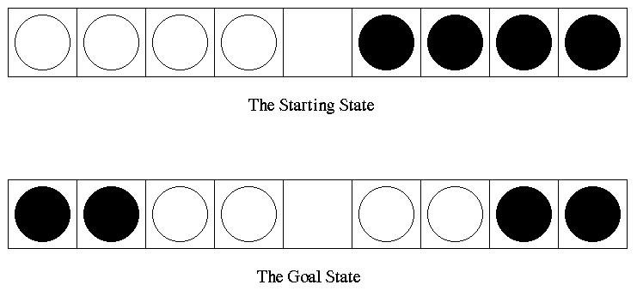

Given the problem, do the following.

- Formulate the problem as an uninformed search problem.

- Of the uninformed search methods presented in class, which would be most appropriate to use.

- Develop an admissible heuristic that can be used by A* and IDA* to solve the problem.

- List one potential disadvantage of using A* and one potential disadvantage of using IDA*.

COMP 0560: Artificial Intelligence I
Final Exam
Fall 1999

- [10pts] describe how the follow constraint satisfaction techniques operate.

- Forward Checking

- Arc Consistency

- The MAC (Maintaining Arc Consistency) Algorithm

COMP 0560: Artificial Intelligence I
Final Exam
Fall 1999

Chapter 5: Game Playing

- [15pts] Show what MAX’s best first move would be using Alpha-Beta pruning. Make sure that you identify which edges are to alpha/beta pruned.

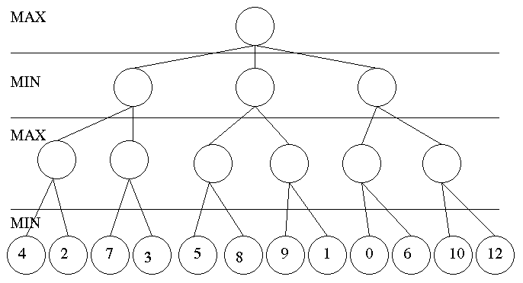

COMP 0560: Artificial Intelligence I
Final Exam
Summer 1999

Chapters 6,7,9: Propositional & First Order Logic

- [10pts] Convert the following sentences into conjunctive normal form.

- ¬(α ∧ (δ∨ε)) ⇒ β ∧ (δ∨ε) ∨ χ ∧ (δ∨ε)

- ¬((¬A ∧ C) ∨ (B ∧ C)) ⇒ ((¬A ∧ ¬D) ∨ (B ∧ ¬D))

COMP 0560: Artificial Intelligence I
Final Exam
Summer 1999

- [15pts] Convert the following sentences into first order logic and use resolution refutation along with Green’s theorem to answer the question: “Who is a millionaire?”.

All who are tall and are athletic are marketable. Those who play basketball are athletic. Jeff plays basketball and his is also tall. Marketable people are millionaires. Jill is athletic

COMP 0560: Artificial Intelligence I
Final Exam
Summer 1999
.

Chapter 18: Learning from Observations

- [4pts] List the 4 conceptual components of a learning agent.

- [10pts] Given the following training set compute the entropy and the gain for attributes A and B. Of the two attributes which should be the root of the induction tree (Show your work)?

A | B | Desired Output
+ | + | +
- | + | +
- | + | -
+ | - | +

COMP 0560: Artificial Intelligence I
Final Exam
Fall 1999

- [10pts] Diagram the version space that corresponds to S={(?,+,-,t)} and G={(?,+,?,?)}, where S and G denote the most specific and most general hypotheses of the version space.

Evolutionary Computation

- [12pts] Name three individuals that were pioneers in the field of evolutionary computation and the evolutionary technique that they developed.

COMP 0560: Artificial Intelligence I
Final Exam
Fall 1999

COMP 0560: Artificial Intelligence I
Final Exam
Fall 1999

COMP 0560: Artificial Intelligence I
Final Exam
Fall 1999

